**EASSY PROGRAMS**

**PROGRAMMING IN JAVA FOR GAMING**

**(CSA0988)**

NAME:K.SHANMUKHA PRIYA

REGISTER NUMBER:192011233

SLOT - C

1.Write a program to reverse a word using loop? (Not to use inbuilt functions)

Sample Input:

String: TEMPLE

Sample Output:

Reverse String: ELPMET

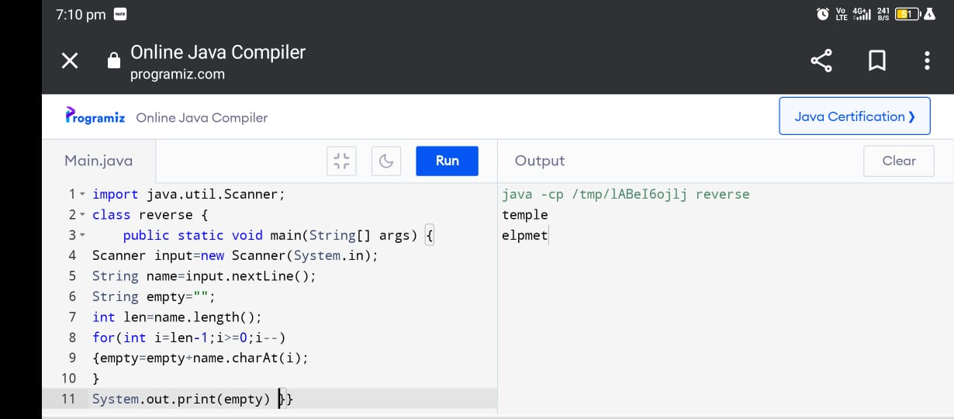

2.Write a program to check the entered user name is valid or not. Get both the inputs from the user.

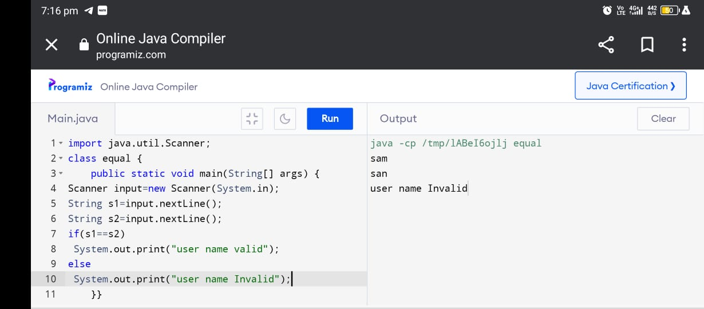

3.Write a program that would sort a list of names in alphabetical order Ascending or Descending, choice get from the user?

Sample Input:

Banana

Carrot

Radish

Apple

Jack

Order(A/D) : A

Sample Output:

Apple

Banana

Carrot

Jack

Radish

Program:

import java.util.Scanner;

class sort

{

public static void main(String[] args)

{

Scanner sc=new Scanner(System.in);

int n;

System.out.print("Enter the no. strings you want to Enter: ");

n= sc.nextInt();

String[] s1=new String[n];

String temp;

System.out.println("Enter the strings: ");

for(int i=0;i<n;i++)

s1[i]=sc.next();

System.out.print("Enter the order D/A: ");

char ch=sc.next().charAt(0);

if(ch=='D'){

for(int i=0;i<n-1;i++)

for(int j=i+1;j<n;j++)

if(s1[i].compareTo(s1[j])<0)

{

temp=s1[i];

s1[i]=s1[j];

s1[j]=temp;

}

}

if(ch=='A')

{

for(int i=0;i<n-1;i++)

for(int j=i+1;j<n;j++)

if(s1[i].compareTo(s1[j])>0)

{

temp=s1[i];

s1[i]=s1[j];

s1[j]=temp;

}

}

for(int i=0;i<n;i++)

System.out.print(s1[i]+" "+"\n");

}

}

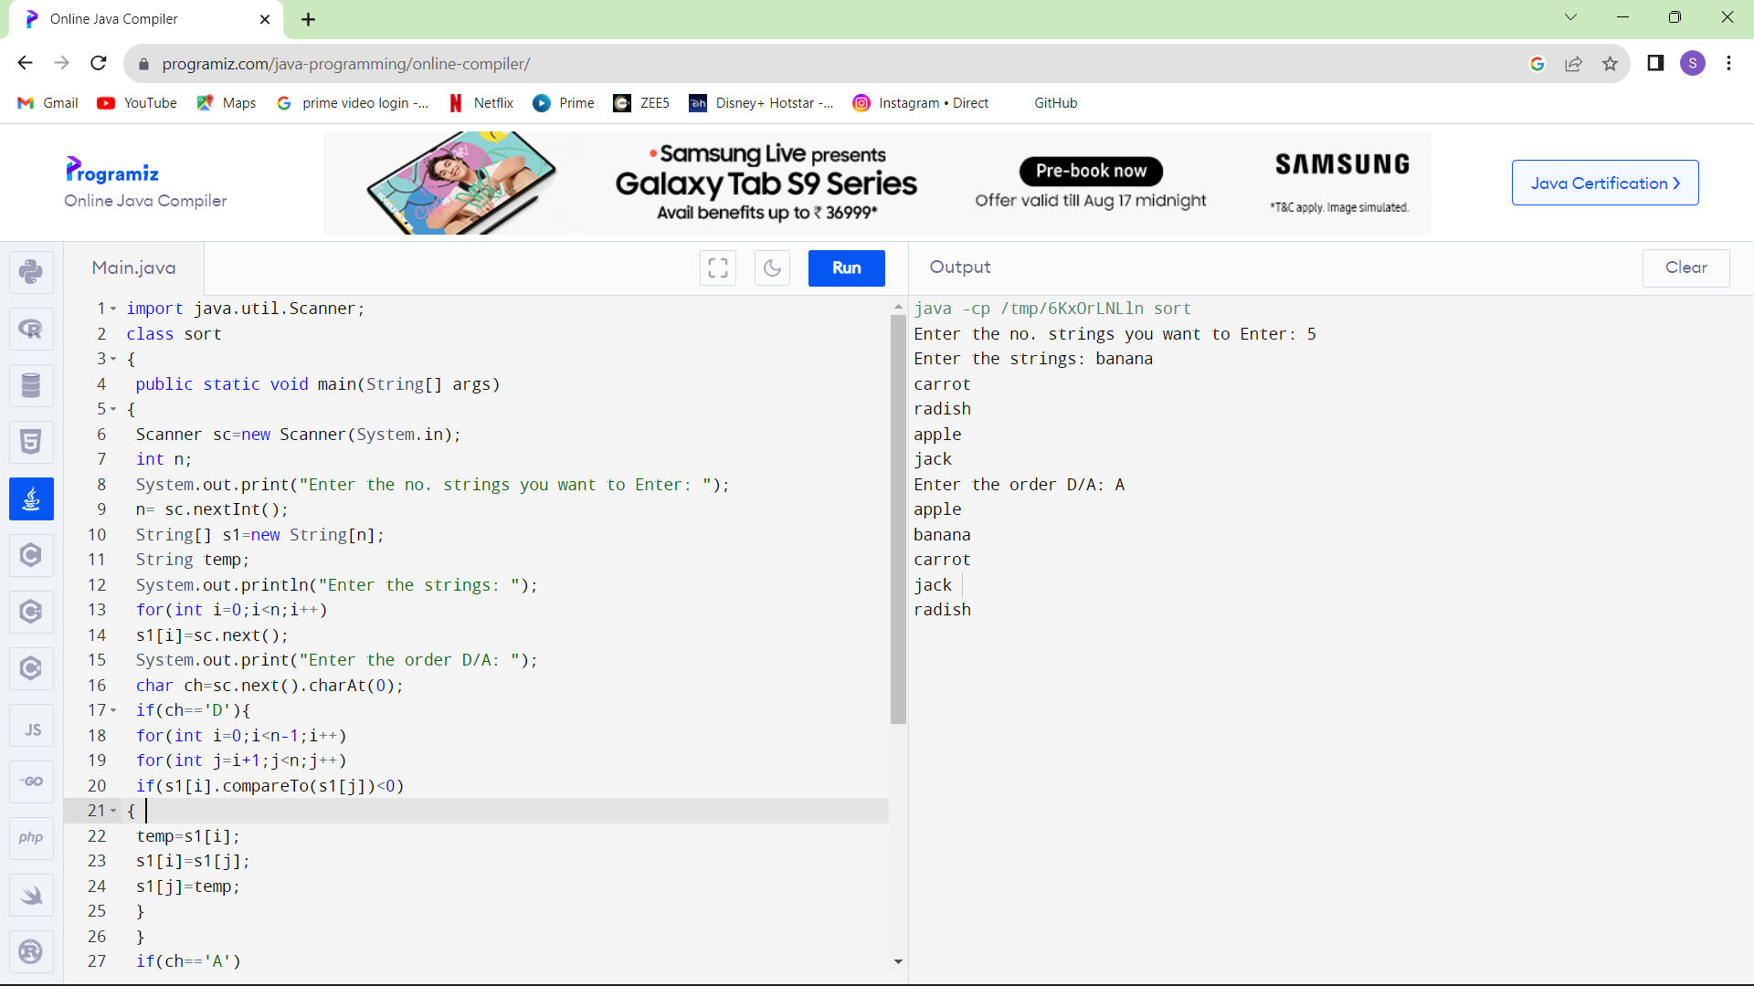

4.Write a program to print the special characters separately and print number of Special characters in the line?

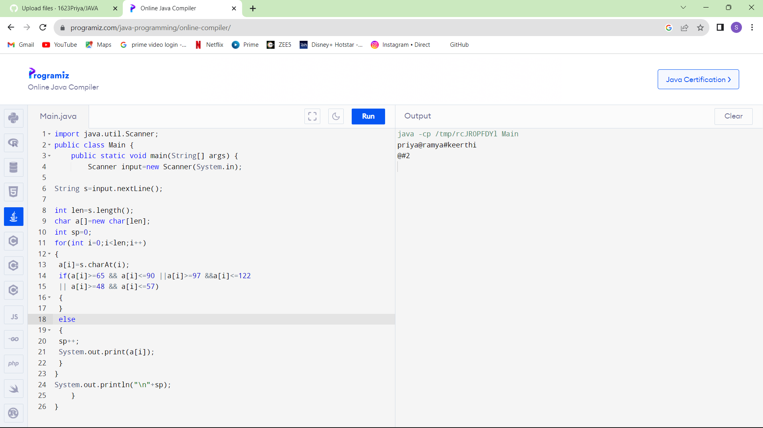

5.Write a program to print the number of vowels in the given statement?

Sample Input:

Saveetha School of Engineering

Sample Output:

Number o vowels = 12

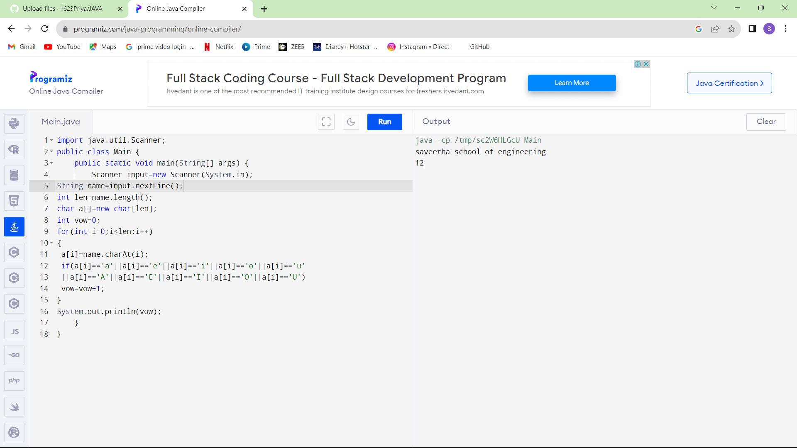

6.Write a program to print consonants and vowels separately in the given word

Sample Input:

Given Word: Engineering

Sample Output:

Consonants: n g n r n g

Vowels: e i e ei

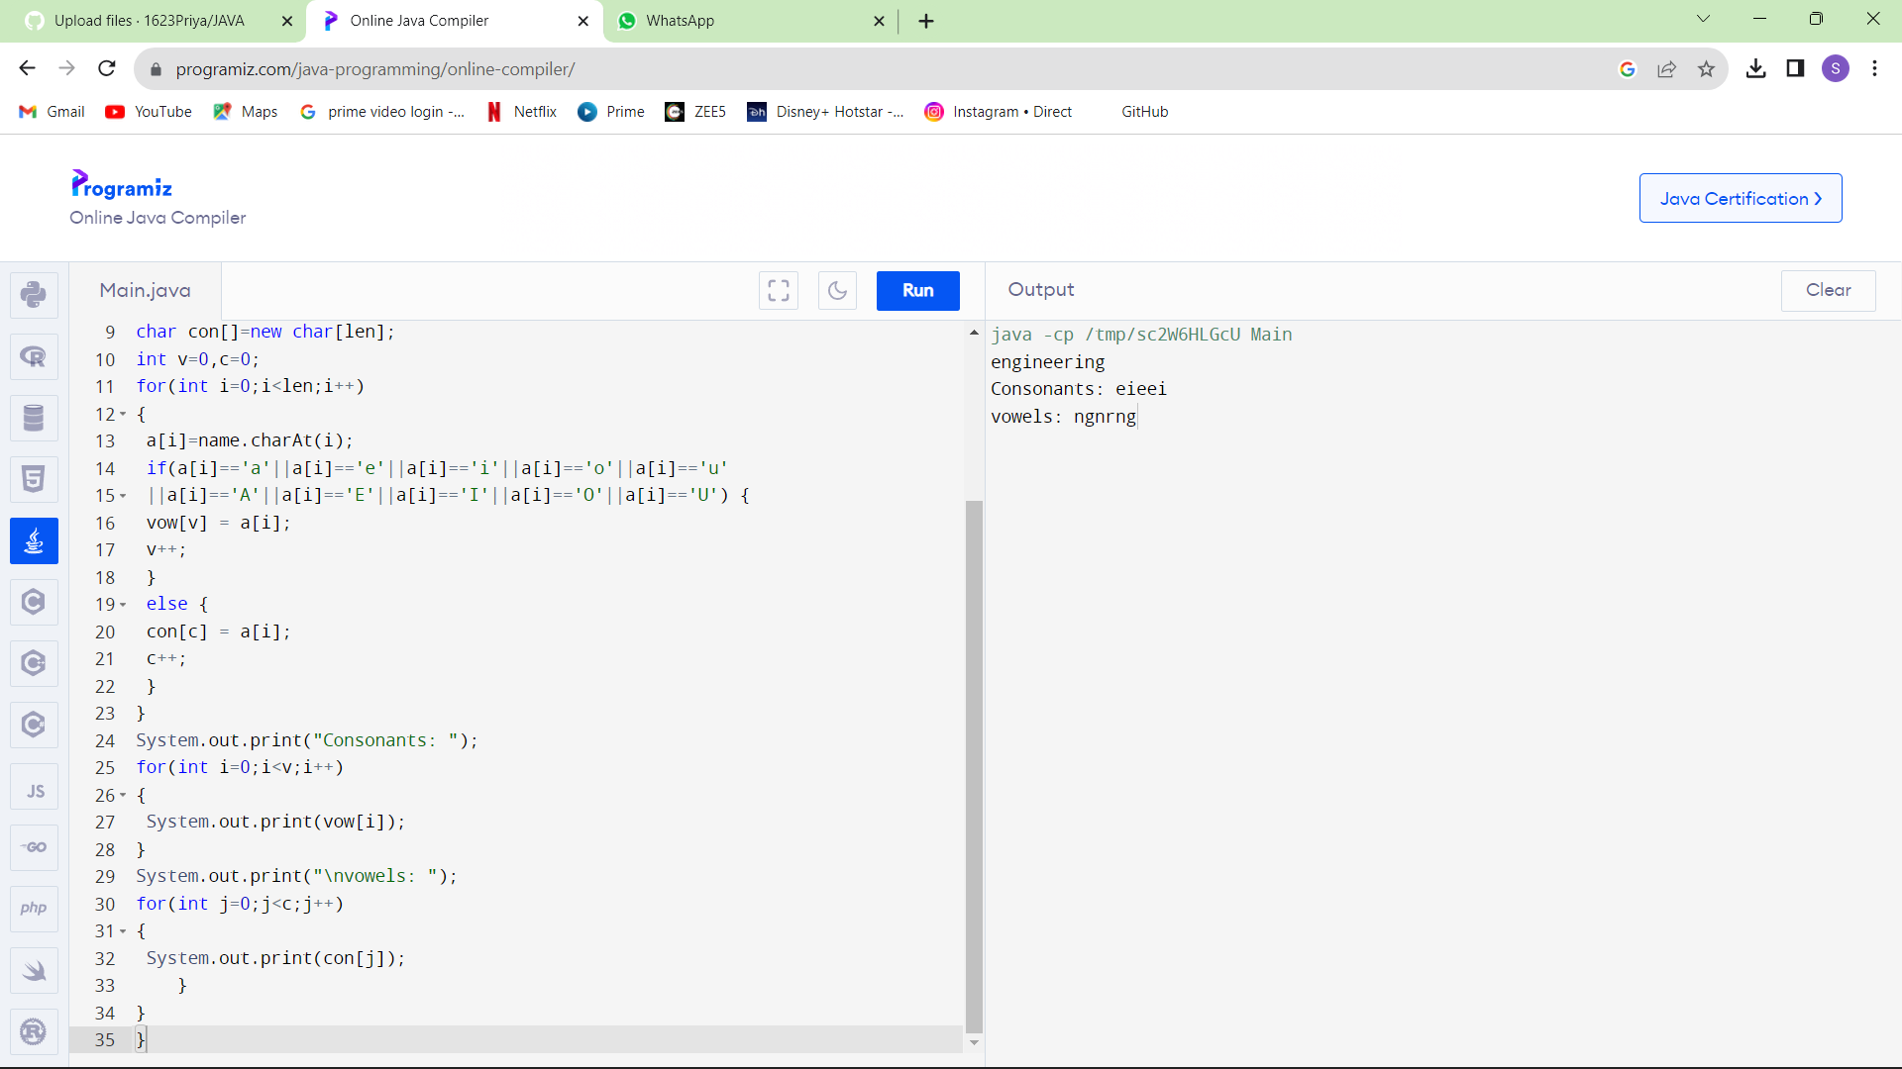

7.Write a program that finds whether a given character is present in a string or not. In case it is present it prints the index at which it is present. Do not use built-in find functions to search the character.

Sample Input:

Enter the string: I am a programmer

Enter the character to be searched: p

Sample Output:

P is found in string at index: 8

Note: Check for non available Character in the given statement as Hidden Test case.

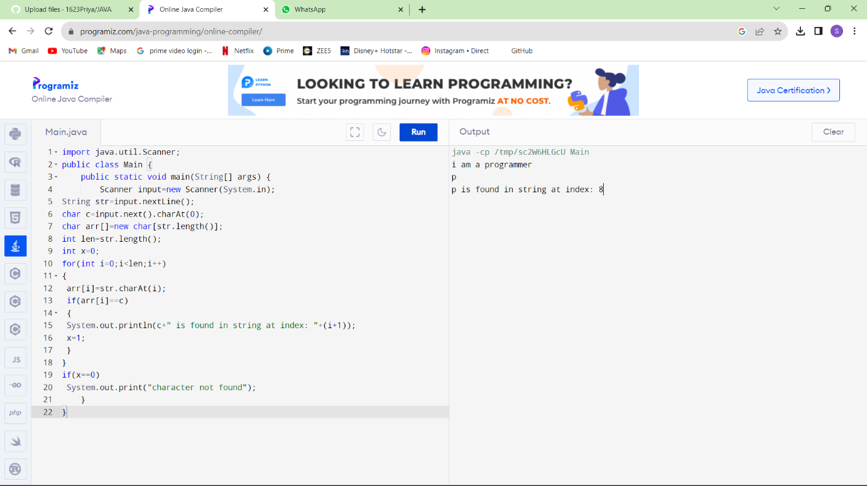

8.Write a program to arrange the letters of the word alphabetically in reverse order

Sample Input:

Enter the word: MOSQUE

Sample Output:

Alphabetical Order: U S Q O M E

Test Case:

1. HYPOTHECATION
2. MATRICULATION
3. MANIPULATION

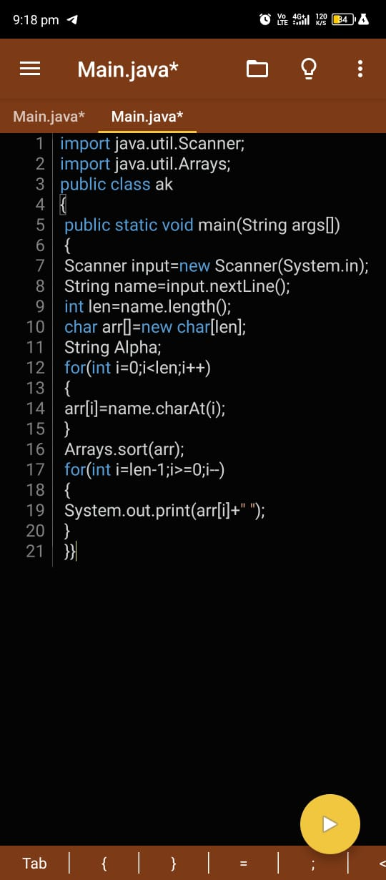

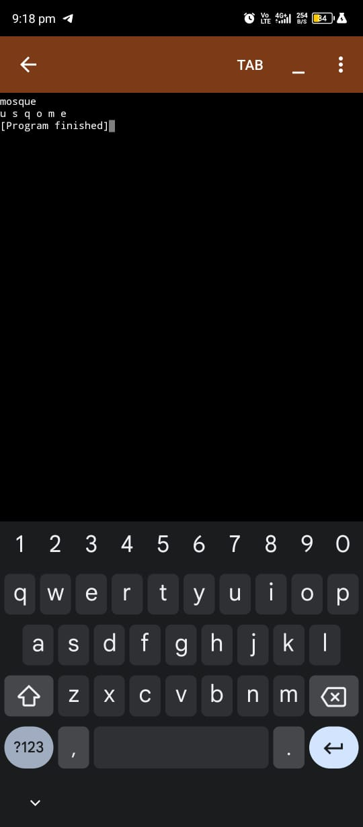

9.Write a program that accepts a string from user and displays the same string after removing vowels from it.

Sample Input & Output:

Enter a string: we can play the game

The string without vowels is: w cn ply thgm

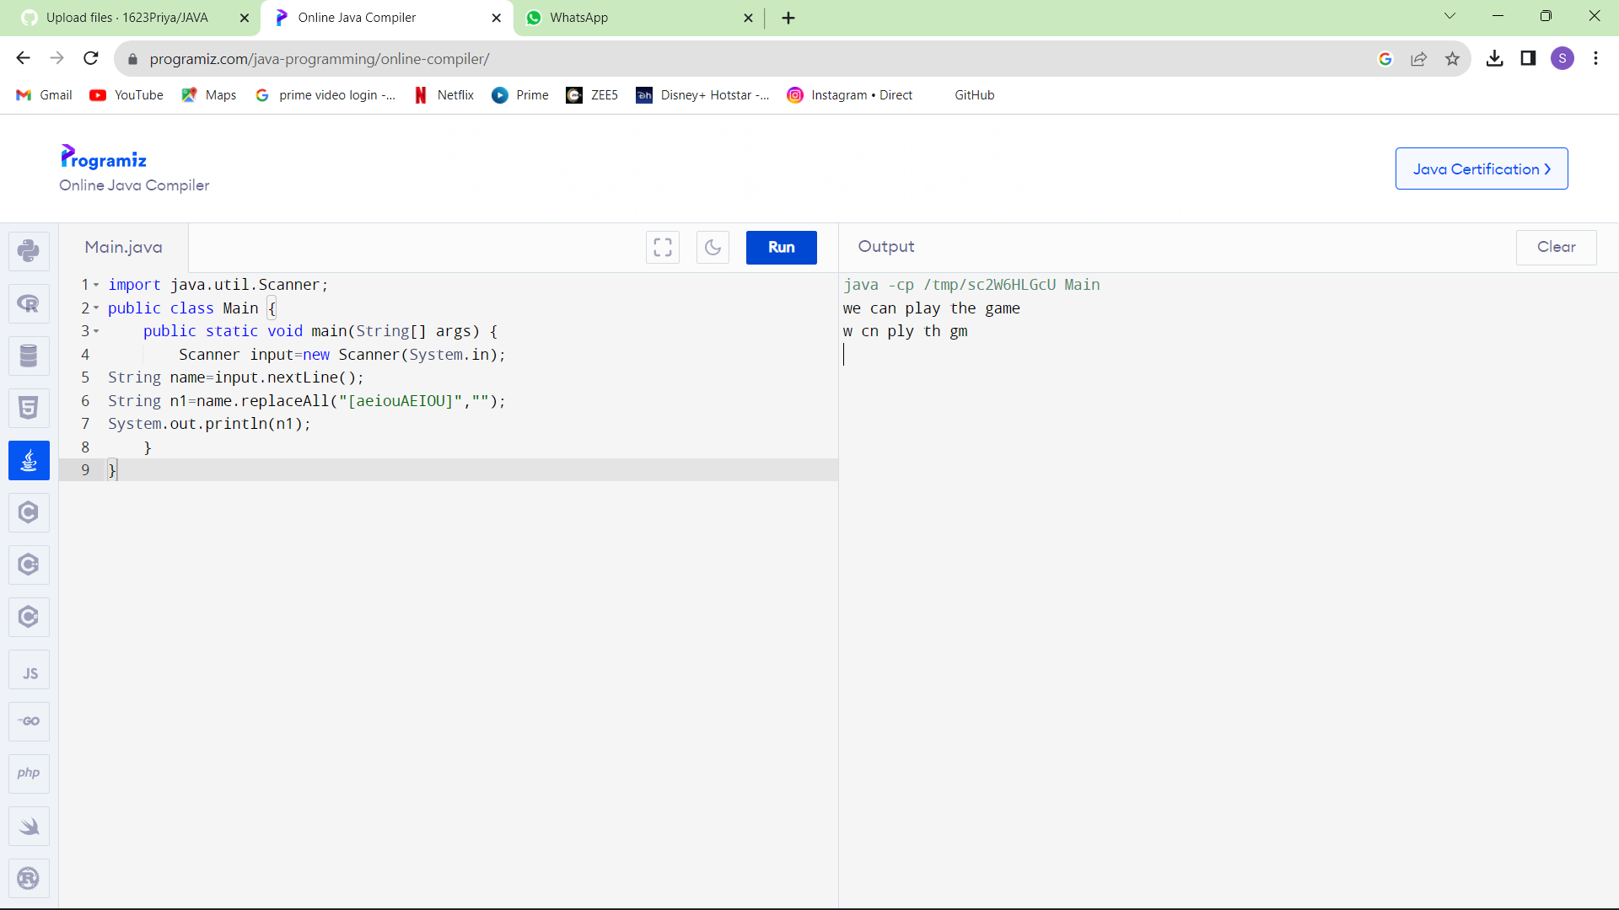

**Arrays:**

10.Write a program for matrix multiplication?

Sample Input:

Mat1 = 1 2

5 3

Mat2 = 2 3

4 1

Sample Output:

Mat Sum = 10 5

22 18

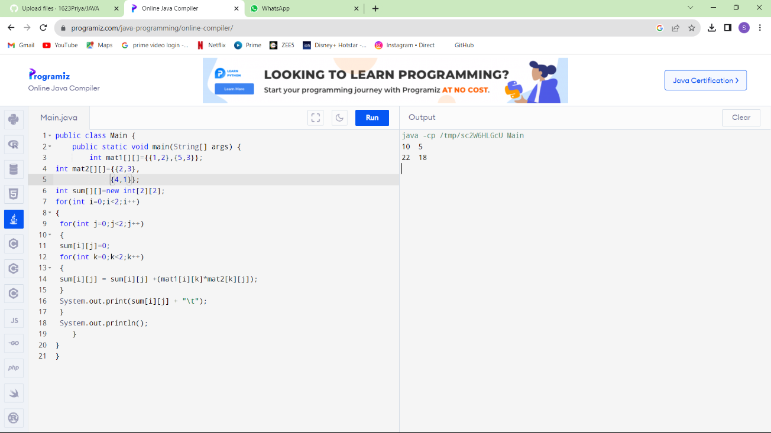

11.Write a program for matrix addition?

Sample Input:

Mat1 = 1 2

5 3

Mat2 = 2 3

4 1

Sample Output:

Mat Sum = 3 5

9 4

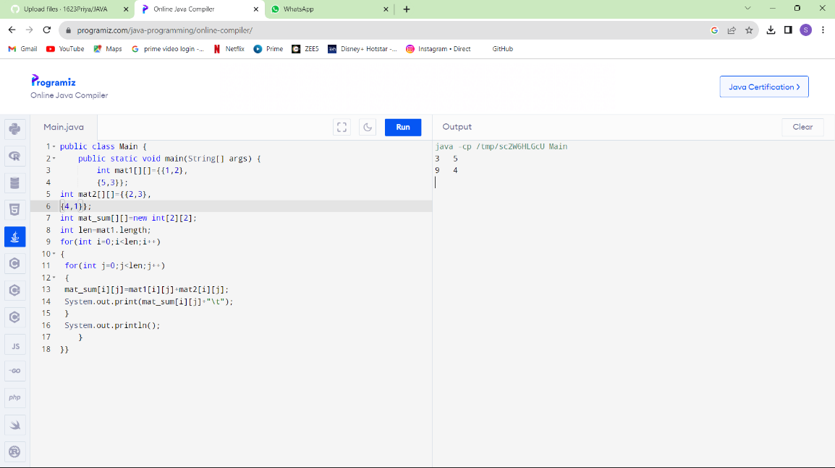

12.Find the Mean, Median, Mode of the array of numbers?

Sample Input;:

Array of elements = {16, 18, 27, 16, 23, 21, 19}

Sample Output:  
Mean = 20

Median = 19

Mode = 16

Test cases:

1. Array of elements = {26, 28, 37, 26, 33, 31, 29}

2. Array of elements = {1.6, 1.8, 2.7, 1.6, 2.3, 2.1, .19}

3. Array of elements = {0, 160, 180, 270, 160, 230, 210, 190, 0}

4. Array of elements = {200, 180, 180, 270, 160, 270, 270, 190, 200}

5. Array of elements = {100, 100, 100, 100, 100, 100, 100, 100, 100}

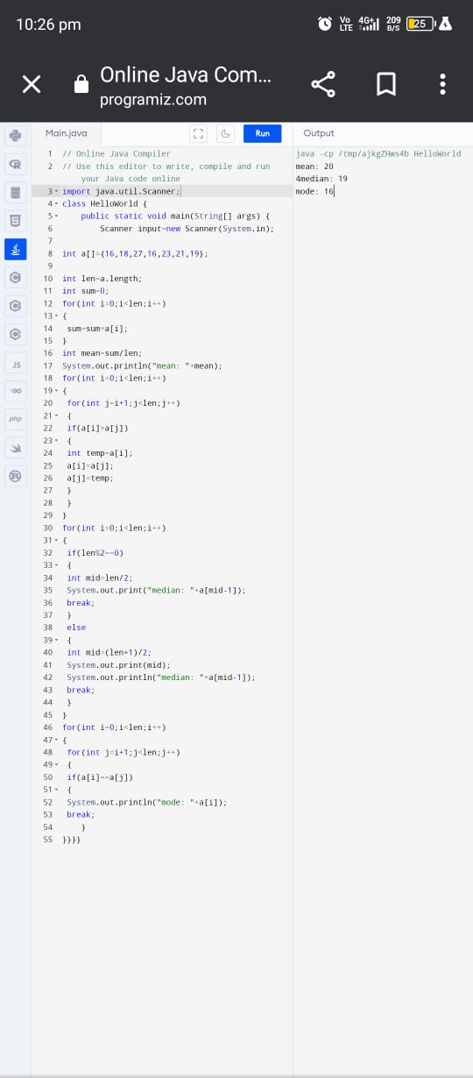

13.Write a program to find the number of composite numbers in an array of elements

Sample Input;:

Array of elements = {16, 18, 27, 16, 23, 21, 19}

Sample Output:  
Number of Composite Numbers = 5

Test cases:

1. Array of elements = {26, 28, 37, 26, 33, 31, 29}

2. Array of elements = {1.6, 1.8, 2.7, 1.6, 2.3, 2.1, .19}

3. Array of elements = {0, 160, 180, 270, 160, 230, 210, 190, 0}

4. Array of elements = {200, 180, 180, 270, 270, 270, 190, 200}

5. Array of elements = {100, 100, 100, 100, 100, 100, 100, 100}

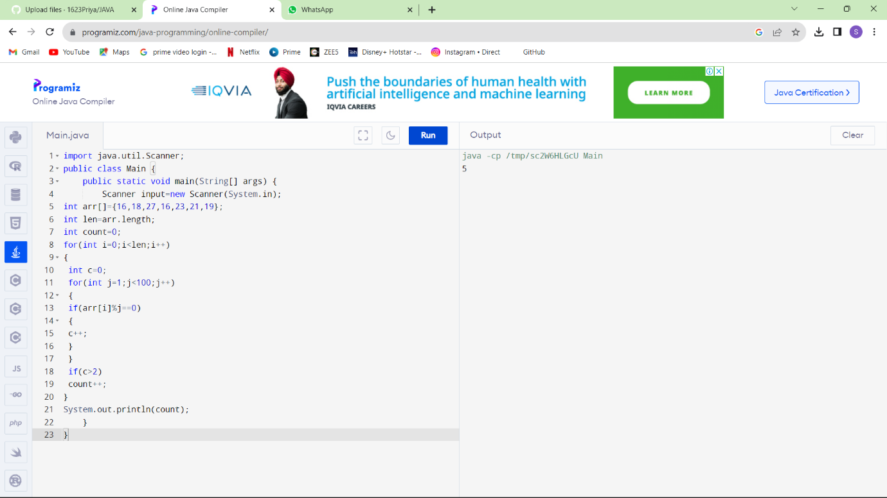

**Patterns :**

14.Write a program to print Right Triangle Star Pattern

Sample Input:: n = 5

Output:

*

* *

* * *

* * * *

* * * * *

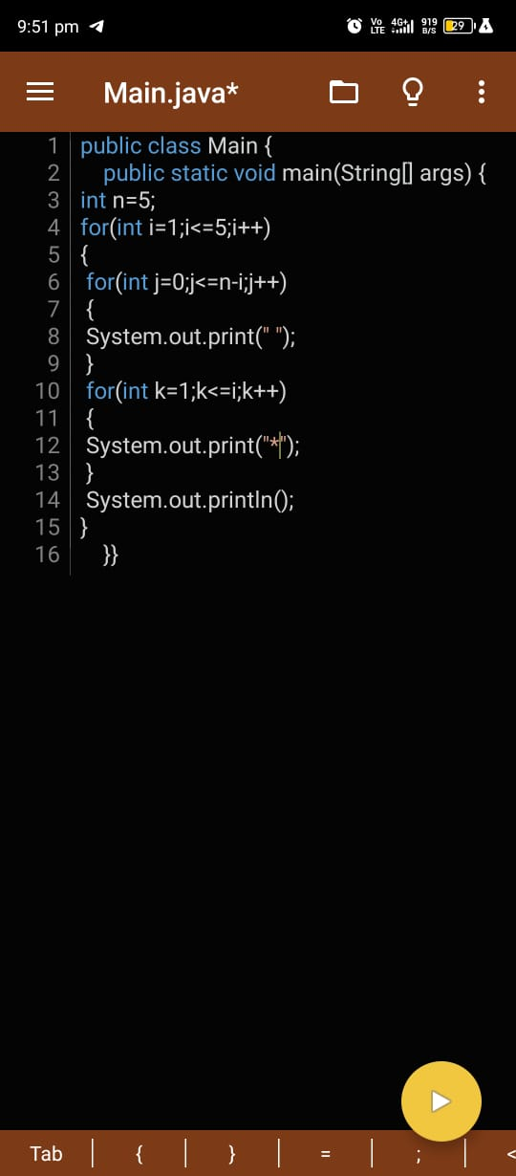

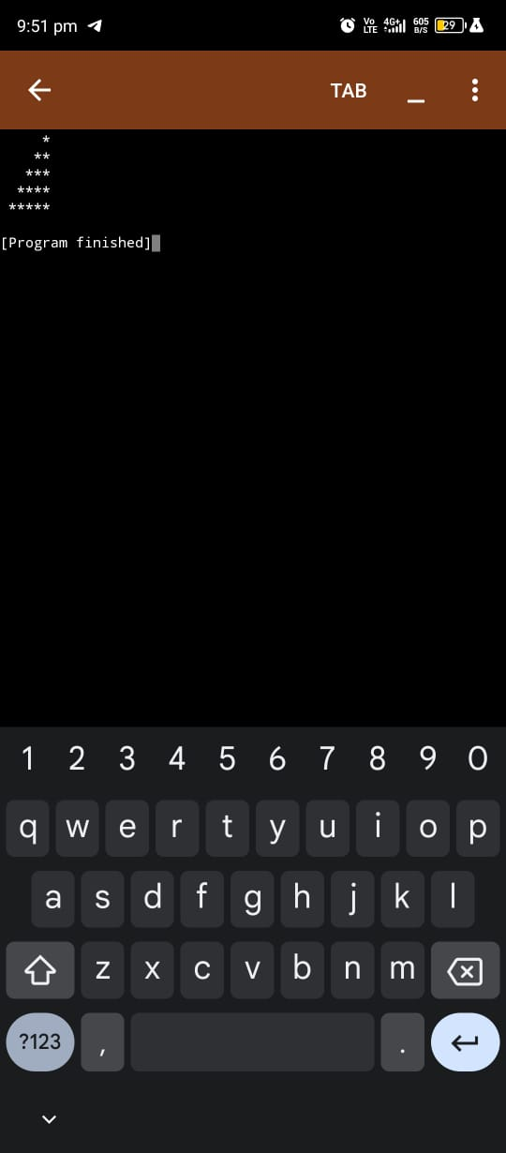

15.Write a program to print the below pattern?

|  |  |  |  |  |  |  |  |  |
| --- | --- | --- | --- | --- | --- | --- | --- | --- |
|  |  |  |  | 1 |  |  |  |  |
|  |  |  | 1 |  | 1 |  |  |  |
|  |  | 1 |  | 2 |  | 1 |  |  |
|  | 1 |  | 3 |  | 3 |  | 1 |  |
| 1 |  | 4 |  | 6 |  | 4 |  | 1 |
|  |  |  |  |  |  |  |  |  |

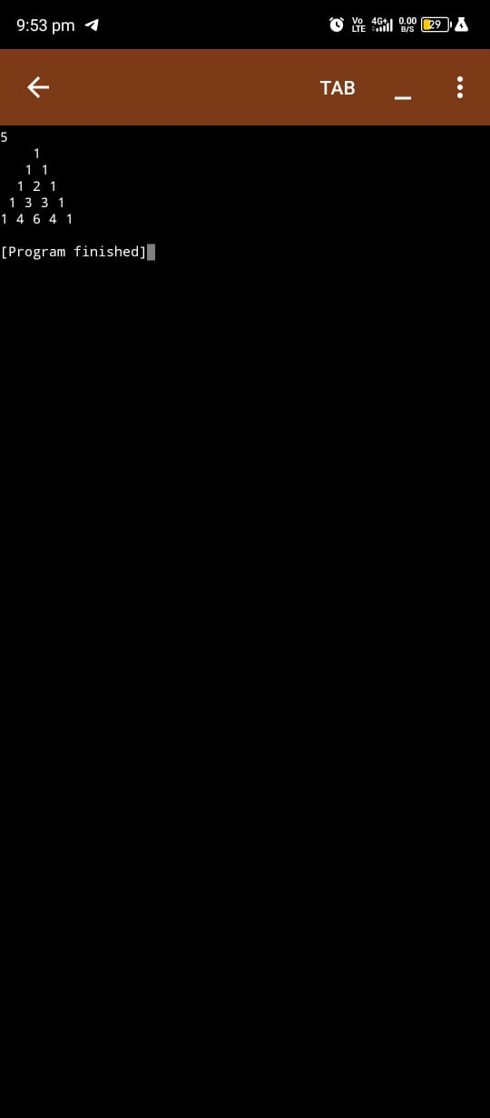

16.Write a program to print rectangle symbol pattern.

Get the symbol as input from user

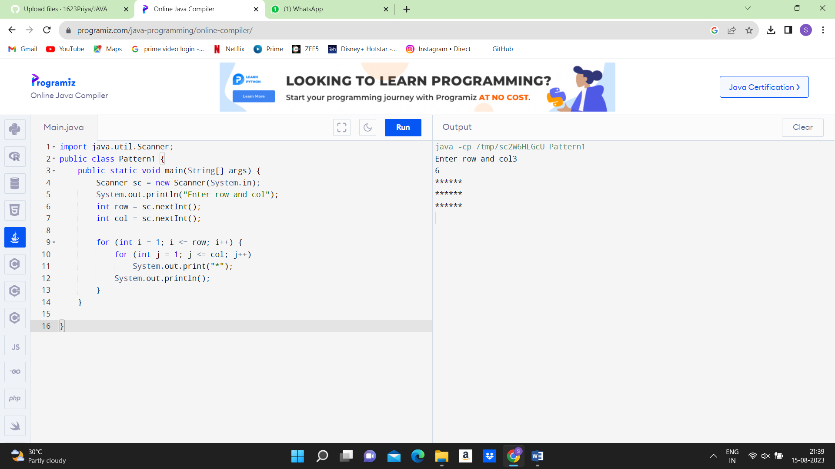

17.Write a program to print the following pattern

Sample Input:

Enter the number to be printed: 1

Max Number of time printed: 3

1

11

111

11

1

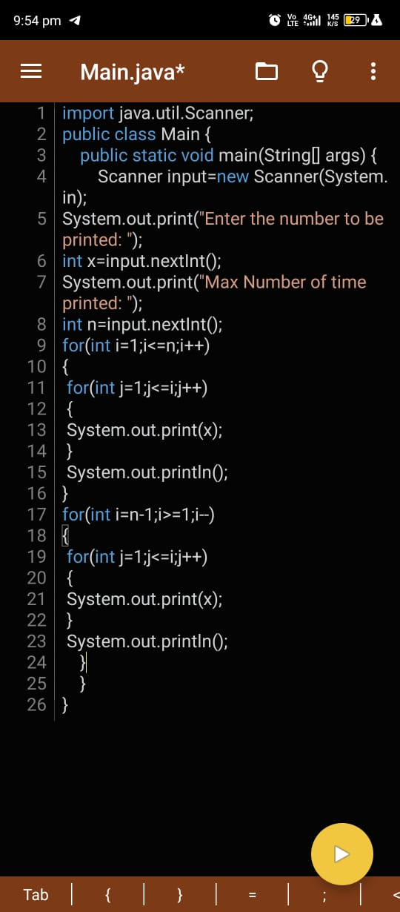

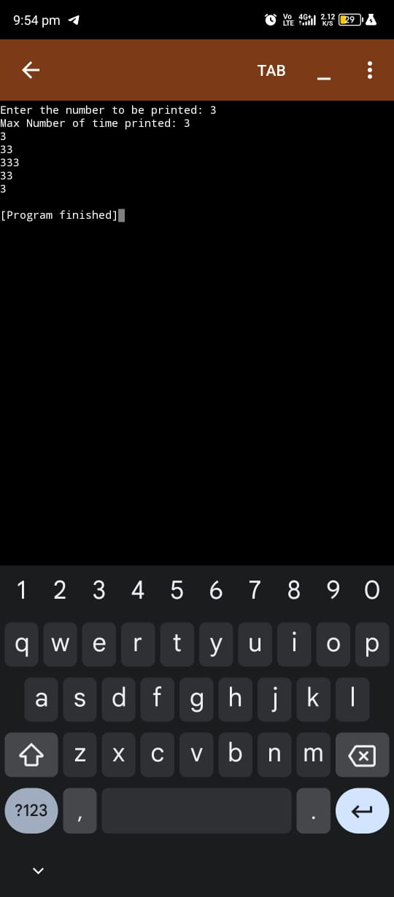

18.Write a program to print the Inverted Full Pyramid pattern?

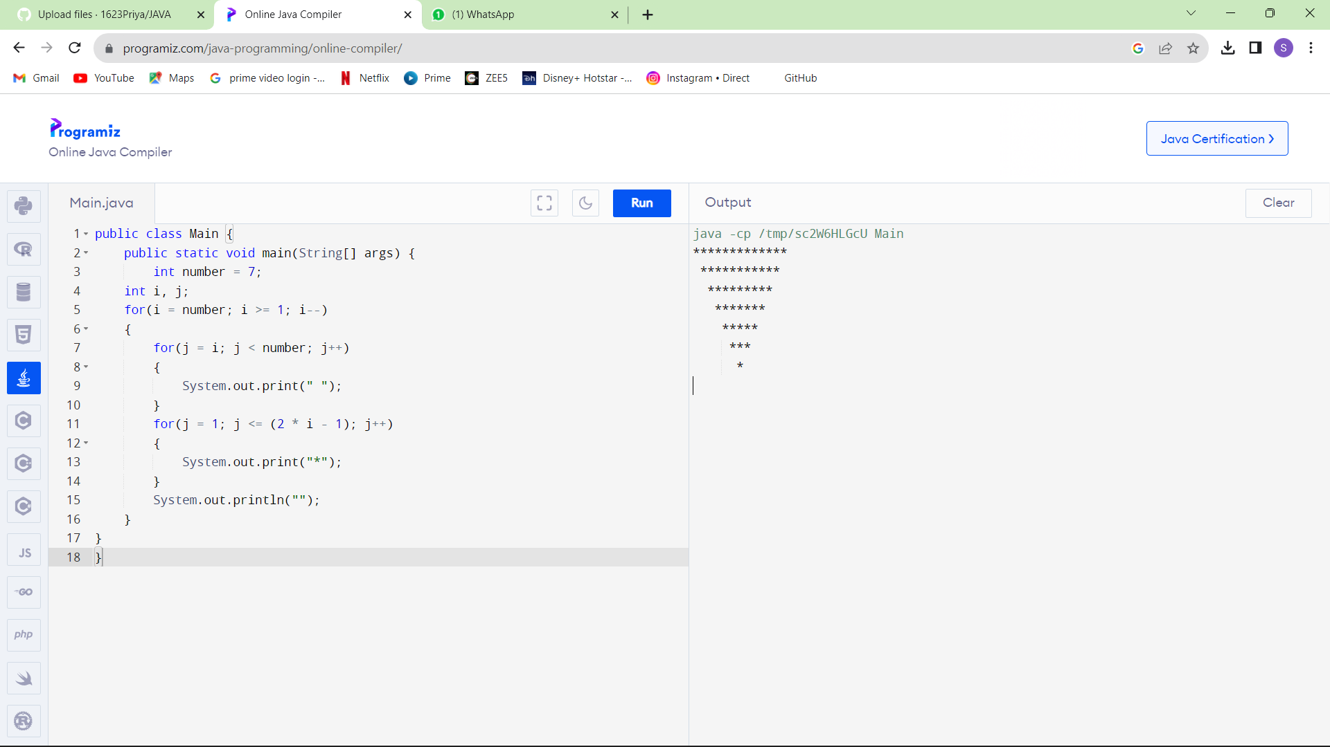

19.Write a program to print the following pattern

Sample Input:

Enter the Character to be printed: %

Max Number of time printed: 3

%

% %

% % %

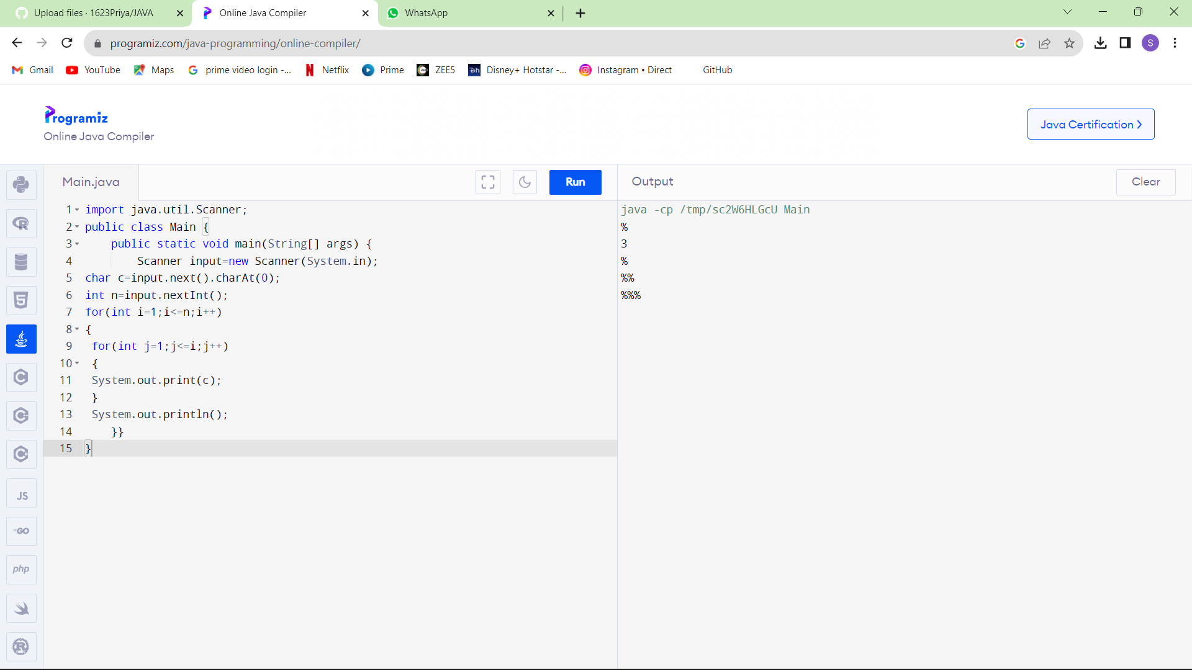

20.Write a program to print hollow square symbol pattern?

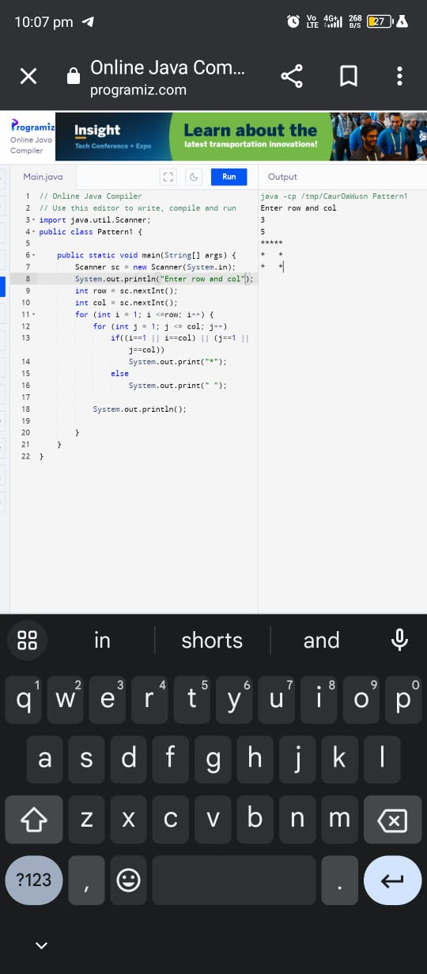

21.Write a program to print the below pattern

1

2 2

3 3 3

4 4 4 4

